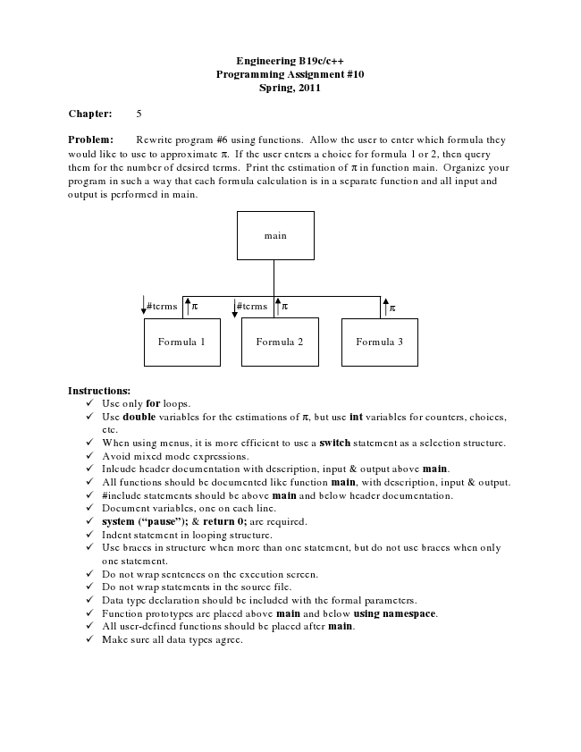

**Engineering B19c/c++ Programming Assignment #10 Spring, 2011**

**Chapter: 5**

Problem: Rewrite program #6 using functions. Allow the user to enter which formula they would like to use to approximate π. If the user enters a choice for formula 1 or 2, then query them for the number of desired terms. Print the estimation of π in function main. Organize your program in such a way that each formula calculation is in a separate function and all input and output is performed in main.

**Instructions:**

✓ Use only for loops. ✓ Use double variables for the estimations of π, but use int variables for counters, choices,

etc. ✓ When using menus, it is more efficient to use a switch statement as a selection structure. ✓ Avoid mixed mode expressions. ✓ Inlcude header documentation with description, input & output above main. ✓ All functions should be documented like function main, with description, input & output. ✓ #include statements should be above main and below header documentation. ✓ Document variables, one on each line. ✓ system (“pause”); & return 0; are required. ✓ Indent statement in looping structure. ✓ Use braces in structure when more than one statement, but do not use braces when only

one statement. ✓ Do not wrap sentences on the execution screen. ✓ Do not wrap statements in the source file. ✓ Data type declaration should be included with the formal parameters. ✓ Function prototypes are placed above main and below using namespace. ✓ All user-defined functions should be placed after main. ✓ Make sure all data types agree.

main

#terms π

#terms π π

Formula 1 Formula 2

Formula 3